**BIT706 Programming III Assessment 1 Christopher Tipper 3525331**

**Part A:**

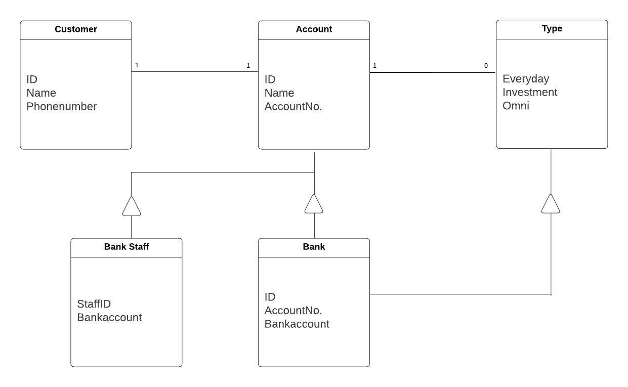

The UML design diagram is being designed this why and the justification for this process is because we have chosen to use the inheritance in all the diagram for the bank and account(s). The reason inheritance is the choice over association is because we have multiple classes for the customers with different accounts in the banks. The type accounts holds the different accounts the user can have which will include the information and details.